A User’s Guide to

XMAX

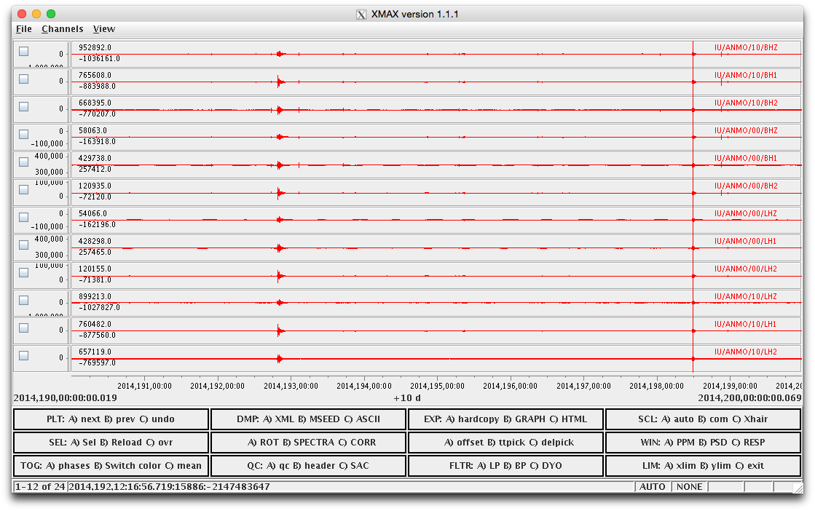

for XMAX version 1.1.1

**updated August 29, 2013**

Mouse

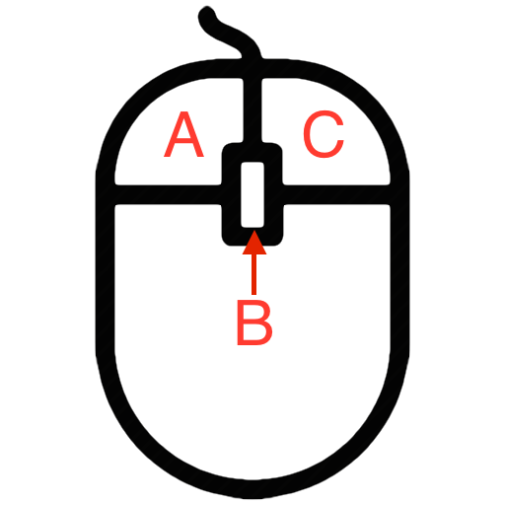

A, B and C corresponds to the mouse buttons from left to right. So, obviously there are issues with 2-button mouses and such.



NOTE: to "zoom in" you press the "A" button and drag a highlighted segment. This is not box specific, just drag in any panel. It will highlight what will be the new segment once re-plotted.

Boxes and buttons

PLT – Plot

A) "next", transition to the next station in the set. When you open the program the first station will be plotted.

B) "prev", transition to the previous station in the set.

C) "undo", toggle back many of the commands such as zoom, one operation at a time. For instance, if you "zoomed in" three times and selected 2 panels with a 4th operation it would take 4 "undo" commands to return to the original presentation.

SEL - Select

A) “Sel”, select a panel or multiple panels by clicking in the upper left hand corner box then hit the "A" button. Now only the selected panels are plotted. Either hit the "A" button again to toggle out or the "undo" to go back to original presentation.

B) “Reload”, reloads the original data set.

C) Overplot, Check the upper left hand corner boxes and hit "C" to overplot all data in one panel.

TOG (toggle)

A) toggle on and off earthquake phases for plotted events.

B) “Switch color”. The default is multiple colors for each data break (e.g. gappy data). Switch color toggles you back to just black regardless of the data breaks.

C) “Mean”, toggle for removing and adding mean in all panels.

DMP - Dump Data

A) “XML” dumps data in XML format

B) “MSEED” dumps data in mseed format

C) “ASCII” dumps data ASCII format

2nd Column, 2nd Row

A) “ROT”, rotate selected data. Not sure if this is fully functional.

B) “SPECTRA”, spectral plot for selected data

C) “CORR”, correlation plot for selected data

QC - Quality Control

A) “qc” ??

B) “header” ??

C) “SAC” ??

EXP - Export

A) “hardcopy”, send to printer

B) “GRAPH”, dump to image file (bmp, png or jpg)

C) “HTML”, dump to file (html)

3rd Column, 2nd Row

A) “offset”; unsure of the purpose. It seems to offset all the data in a positive direction. Possibly this was suppose to be a means of slowly separating over plotted traces but it does not work that way. In that case it just offsets both.

B) “ttpick”, toggle on a picking function. Hit "B" then click on the pick location, that pick is then written to a file.

C) “delpick”, delete the last pick.

FLTR - Filter

A) LP is a canned low pass; probably a 4 pole low pass at .1hz

B) BP is a canned band pass to accentuate P-wave energy.

C) DYO is design your own filter. The operator chooses 3 values from a pop up (high and low freq and order).

SCL - Data Scale within the panels

A) “auto”, channels are auto scaled to the individual limits of each panel

B) “com”, all channels share a common scale; max scale is determined by the largest value and all others are plotted on that same scale.

C) “Xhair”, crosshair. It is supposed to work by allowing the user to set Y panel limits by selecting Xhair then selecting the upper and lower limits with the "A" mouse button in the panel. Currently broken.

WIN – Window

A) “PPM” plots the particle motion of two selected traces.

B) “PSD” plots the power spectral density of all selected traces.

C) “RESP” plots the response curves for the instruments associated with the plotted traces.

LIM – Limits

A) “Xlim” is used to set a limit on the x-axis.

B) “Ylim” is used to set a limit on the y-axis.

C) “exit” quits the program.